Real Estate Web Scraping with EDA

In this project we are exploring prices from different real estate websites such as Magic Brick & NoBroker. We are scrapping properties details from both websites and then user can view details with prices.

This project consist of two modules

1. Admin: admin can login to application using username and password as ‘admin’ and ‘admin. After login admin will scrape and define parameters to fetch data from websites and save in database
2. User can sign up with the application and then login and then can view prices and details from both websites and can view variation in prices in graph and tabular format

SCREEN SHOTS

To run project copy content from DB.txt file and then paste in MYSQL console to create database and then double click on ‘run.bat’ file to start python server and get below page

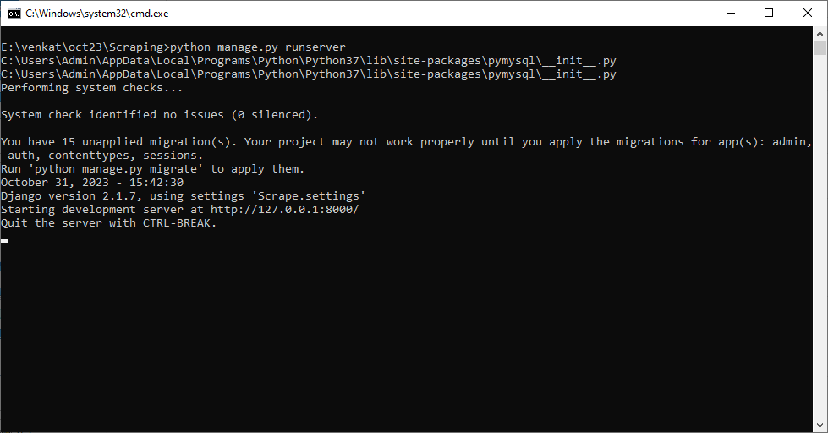

In above screen python server started and now open browser and enter URL as <http://127.0.0.1:8000/index.html> and press enter key to get below page

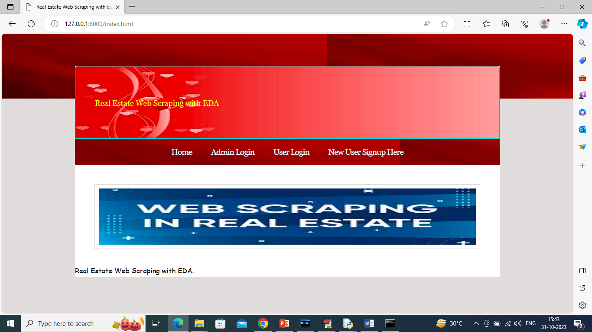

In above screen click on ‘Admin Login’ link to get below page

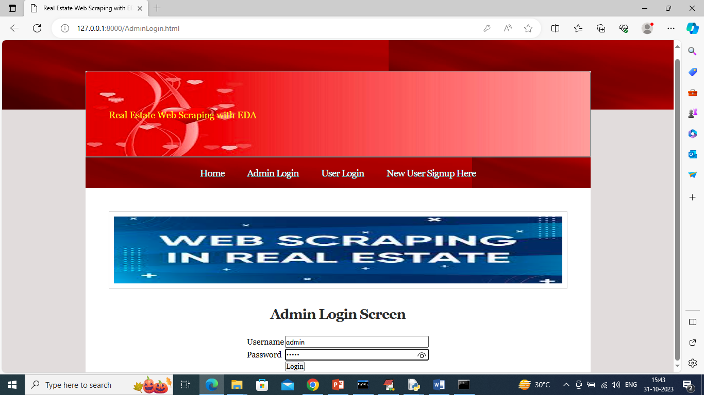

In above screen admin is login and after login will get below page

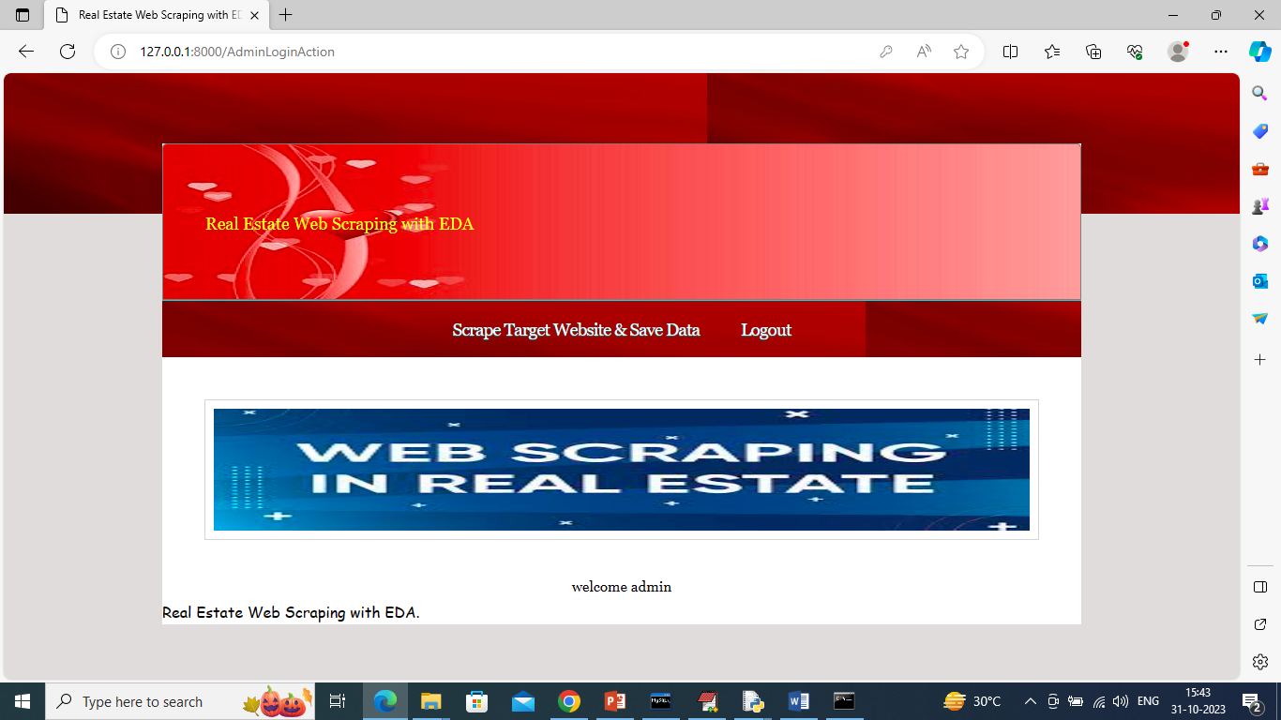

In above screen click on ‘Scrape Target Website & Save Data’ link to get below page

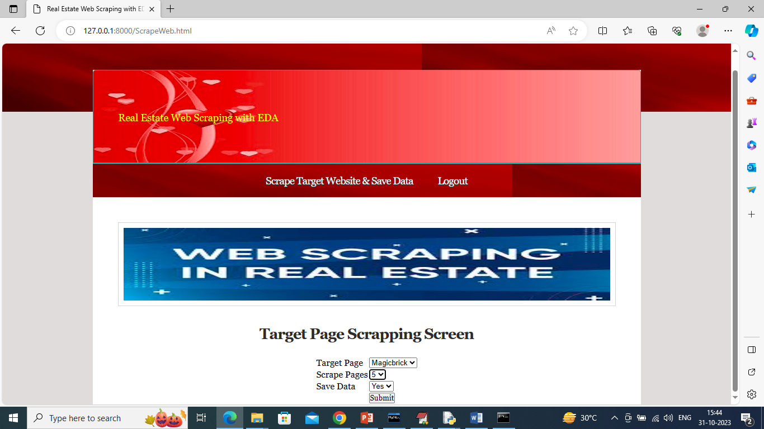

In above screen I selected website as Magic Brick and then selected number of pages with save option and then press button to get below output

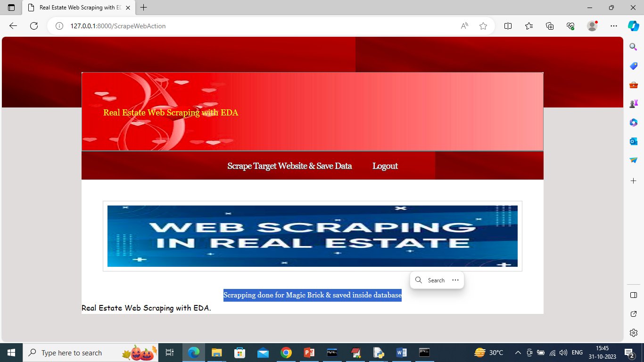

In above screen in blue colour text can see scrape data save in database and similarly we can scrape from other website

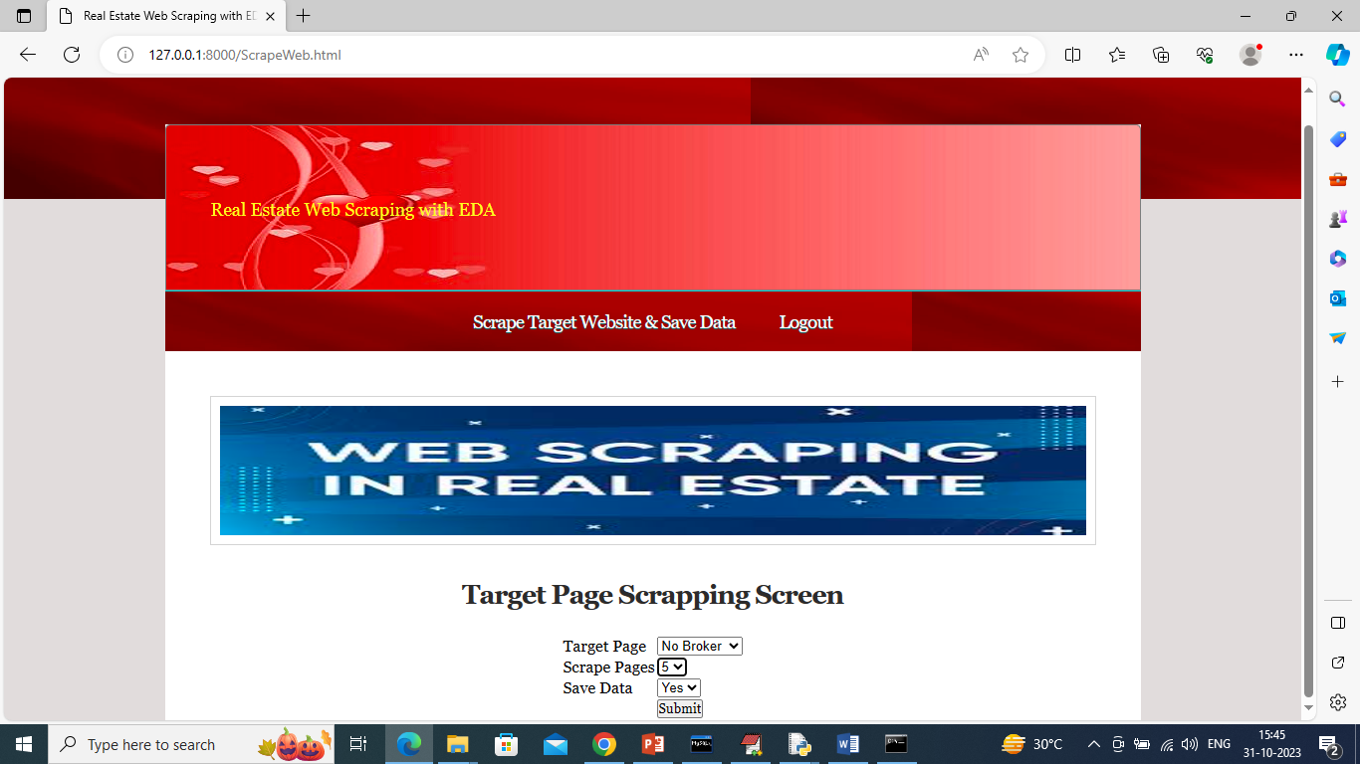

In above screen scraping from ‘No Broker’ site and then press button to get below page

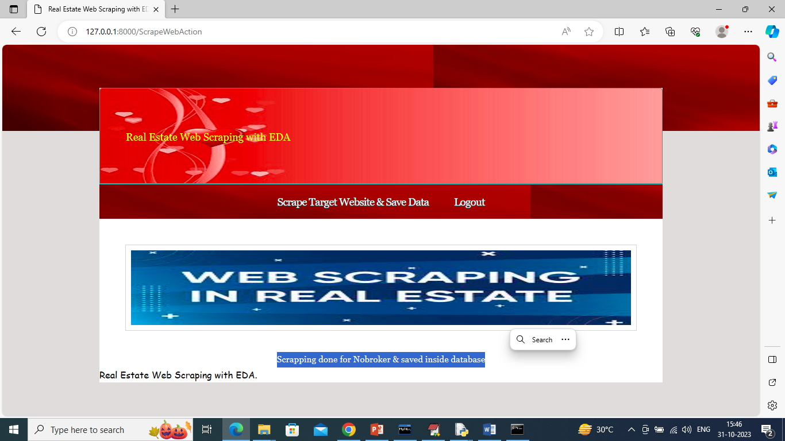

In above screen No Broker data also saved in database and now logout and signup as new user

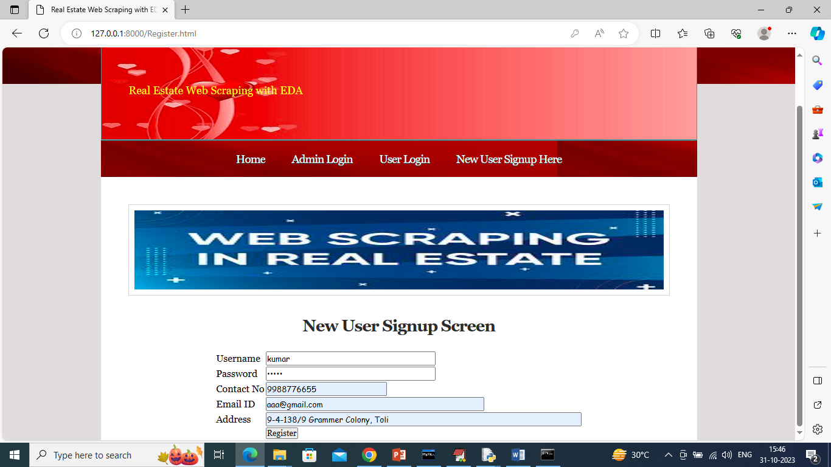

In above screen user is registering and after signup will get below page

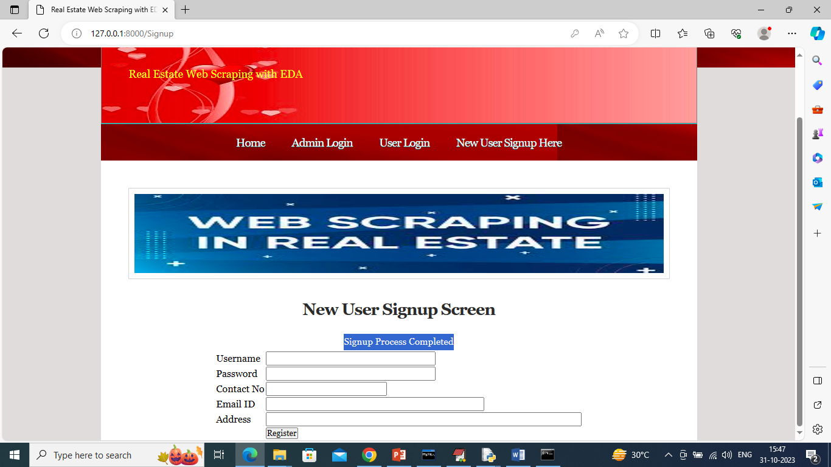

In above screen signup task completed and now click on ‘User Login’ link to get below page

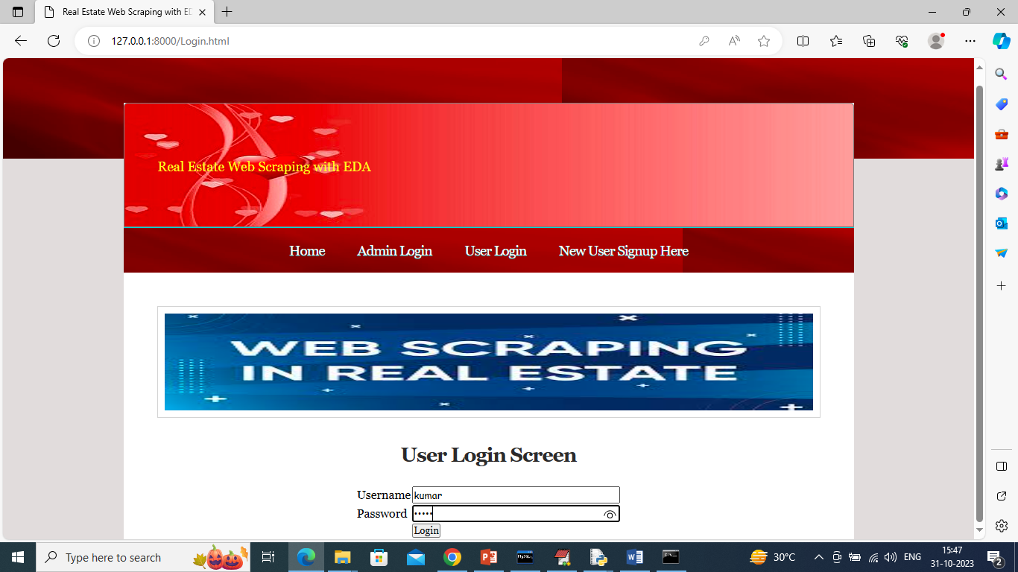

In above screen user is login and after login will get below page

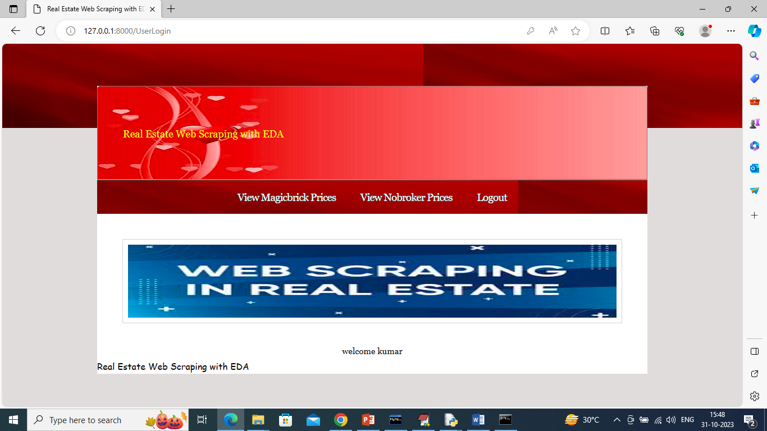

In above screen click on ‘View Magic Brick Prices’ link to view all scrape data and get below output

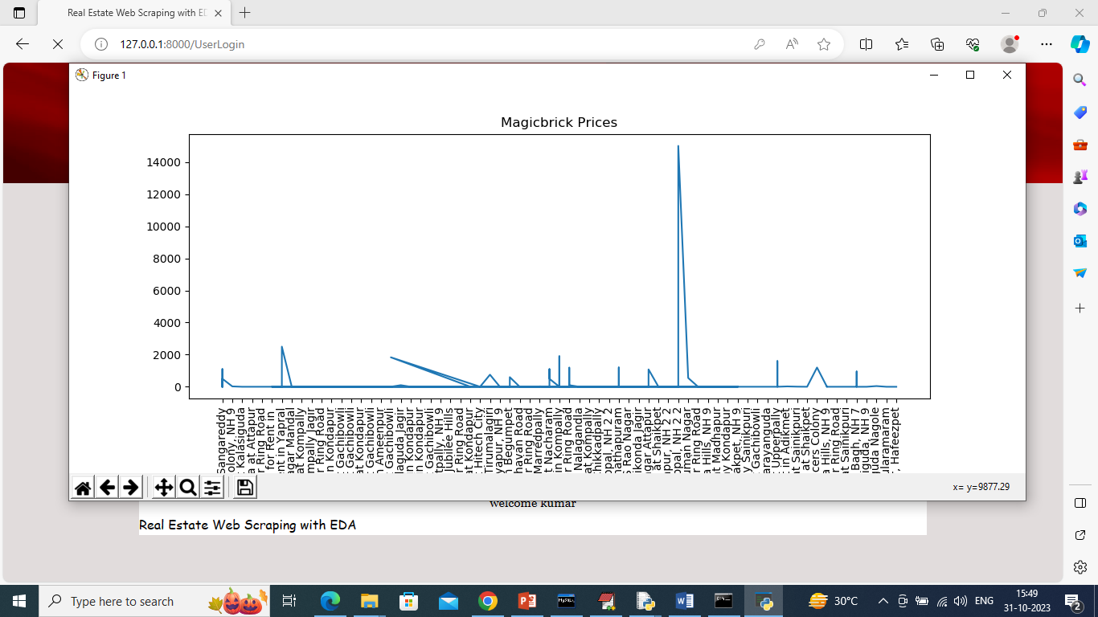

In above graph x-axis represents property names and y-axis represents prices and now close above graph to view Magic Brick property details

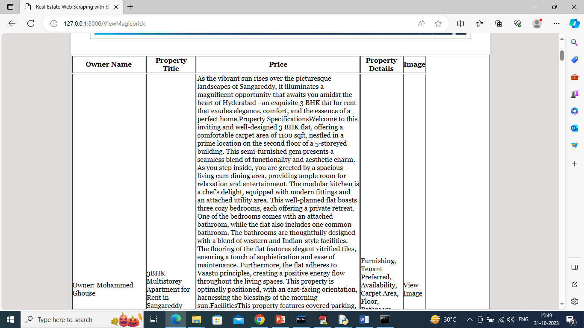

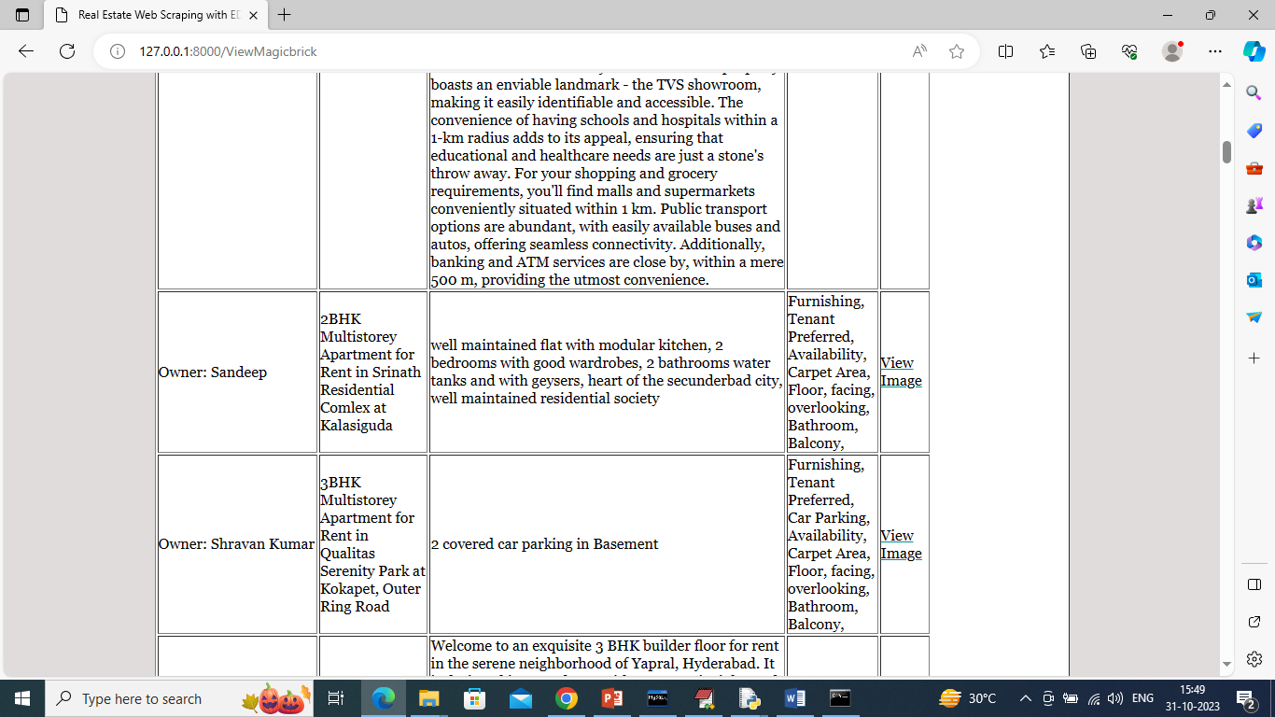

In above screen can read property details from Magic Brick and now click on ‘View No Broker Prices’ link to get below page

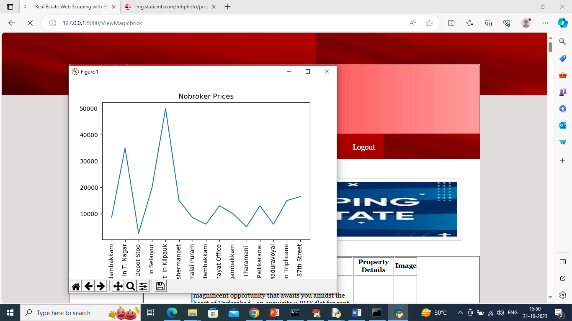

In above graph x-axis represents No broker property names and y-axis represents prices and now close above graph to get below page

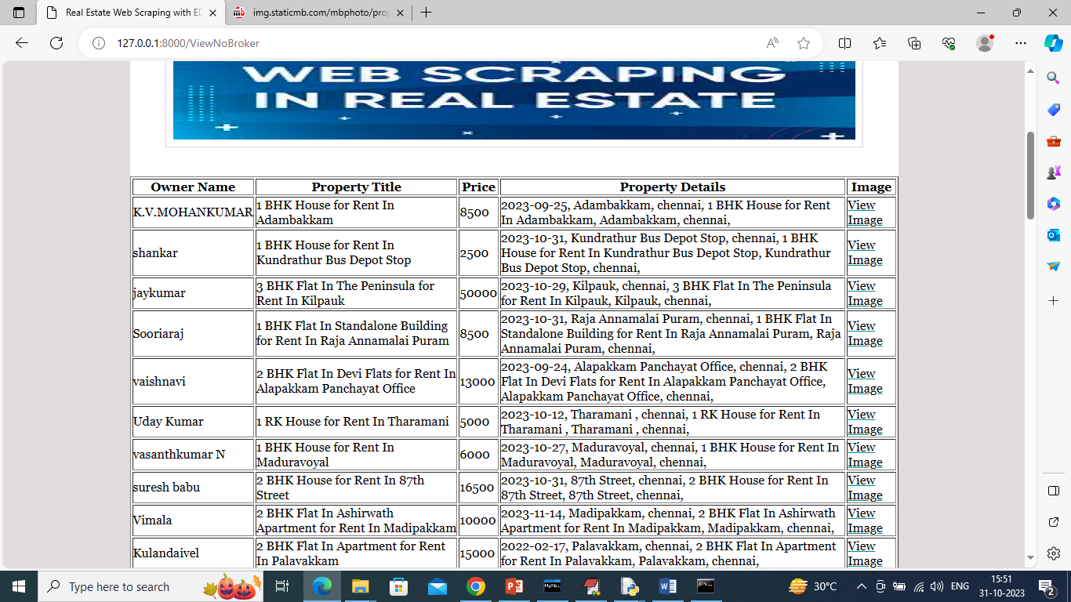

In above screen can see scrape data from NO Broker website. Similarly admin will scrape latest property details and then user will view those details